COMPUTER SCIENCE
GRADE 6
SAMPLE ITEMS
Waseem Aziz, ICB, G-6/3, Islamabad
Muhammad Usman, IMCB, I-8/3, Islamabads

Grade 6 Contents
Domain A: ICT Fundamentals 2
[SLO: CS-06-A-01] 2
Formative Assessment: 2
Summative Assessment: 3
Domain A: ICT Fundamentals 4
[SLO: CS-06-A-02] 4
Formative Assessment: 4
Domain A: ICT Fundamentals 6
[SLO: CS-06-A-03] 6
Formative Assessment: 6
Domain B: Digital Skills 8
[SLO: CS-06-B-01] 8
Formative Assessment: 8
Summative Assessment: 8
Domain B: Digital Skills 9
[SLO: CS-06-B-02] 9
Formative Assessment: 9
Summative Assessment: 9
Domain B: Digital Skills 10
[SLO: CS-06-B-03] 10
Formative Assessment: 10
Summative Assessment: 10
Domain C: Algorithmic Thinking and Problem Solving 11
[SLO: CS-06-C-01] 11
Formative Assessment: 11
Summative Assessment: 11
Domain C: Algorithmic Thinking and Problem Solving 12
[SLO: CS-06-C-02] 12
Formative Assessment: 12
Summative Assessment: 12
Domain D: Programming 13
[SLO: CS-06-D-01] 13
Formative Assessment: 13
Summative Assessment: 13
Domain D: Programming 15
[SLO: CS-06-D-02] 15
Formative Assessment: 15
Summative Assessment: 15
Domain E: Digital Citizenship 16
[SLO: CS-06-E-01] 16
Formative Assessment: 16
Summative Assessment: 16
Domain F: Entrepreneurship in Digital Age 17
[SLO: CS-06-F-01] 17
Formative Assessment: 17
Summative Assessment: 17

Thematic area:

Domain A: ICT Fundamentals

[SLO: CS-06-A-01]
Students will be able to recognize various ICT devices and their application.
Cognitive Level:
Knowledge

Formative Assessment:
(Marks :10)
Q. Write the type (input/output/communication/others) and names of the devices in the grid below:
Picture | Type of Device | Name of Device
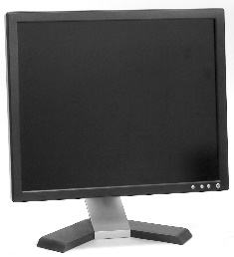
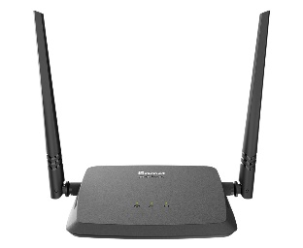
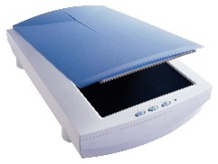
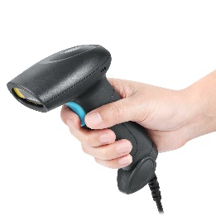
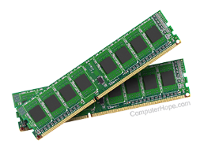

Scoring scheme:
01 mark for correct identification of type and 01 mark for identification of name in each case.

Summative Assessment:
(Marks: 05)
Q. Select the appropriate device (keyboard, mouse, monitor, scanner, speaker, printer, RAM, barcode reader, joystick) from the scenario given below:
Scanning the barcode from a product to check the price
Convert a handwritten document into digital form
Preparing hard copy of document through computer
Display the output in soft form
Input textual data in computer

Scoring scheme:
01 mark of each correct selection.

Thematic area:

Domain A: ICT Fundamentals

[SLO: CS-06-A-02]
Students will be able to define and differentiate between computer hardware and software.
Cognitive Level:
Knowledge

Formative Assessment:
(Marks: 05)
Q. Following is a list of hardware and software. Identify each of them.
Item | Type
Microsoft Word
System Unit
Microsoft Windows
Mouse
Memory Card

Scoring scheme:
Correct categorization of each picture secure one (01) mark.
Summative Assessment:
(Marks: 08)
Q. Write down two differences between hardware and software. And give one example of each.
Scoring scheme:
- marks for each correct difference.
Q. Focus on the following picture of system unit and identify the highlighted areas.
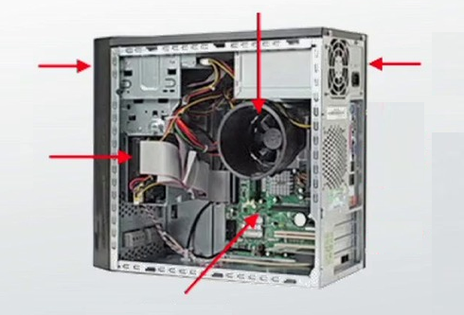

Scoring scheme:
01 mark of each correct label

Thematic area:

Domain A: ICT Fundamentals

[SLO: CS-06-A-03]
Students will be able to identify and analyze (basic) hardware components of a computer system (e.g. processor, memory and storage)
Cognitive Level:
Knowledge

Formative Assessment:
(Marks: 05)
Q. Grid comprising of pictures of hardware components (processor, memory, storage, others). Identify the category.
Picture | Category
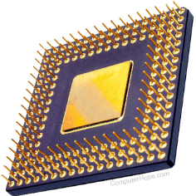
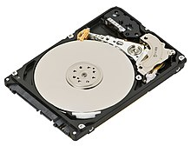
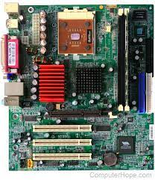
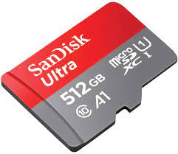

Scoring scheme:
01 mark for each correct name.
Formative Assessment:
(Marks: 08)
Q. Read the functionality of devices and suggest the suitable name of device.
Functionality | Name
Hardware component to perform arithmetic and logic operations inside computer
Non-volatile memory that helps starting the computer.
Storage device uses laser technology to read and write data
Component that holds together all the other components inside system unit
Small and portable storage media used in mobile phones and digital cameras

Scoring scheme:
O1 mark for each correct name.

Q. Write the name of devices (storage, processor and memory) in given boxes according to the flow of information.

Scoring scheme:
01 mark for placing correct name in each box.

Thematic area:

Domain B: Digital Skills

[SLO: CS-06-B-01]
Student will be able to navigate around on operating system (e.g. Microsoft Windows, MAC OS, Linux, Ubuntu, Android, iOS etc.)
Cognitive Level:
Application

Formative Assessment:
(Marks: 10)
Q. Perform the following tasks on computer systems:
- Create a shortcut of a file on the desktop
- Open an application from run command.
- Searching for an installed program through start menu
- Restoring and maximizing a window
- Launching a program from taskbar
Scoring scheme:
02 marks for each task

Summative Assessment:
(Marks: 10)
Q. Write the steps of each of the following task:
- Create a folder
- Copy a file from one folder to another folder
- Move a file from desktop to “C” drive
- Delete a file from desktop
- Rename the folder created at step 1
Scoring scheme:
02 marks for each task

Thematic area:

Domain B: Digital Skills

[SLO: CS-06-B-02]
Student will be able to develop and demonstrate image processing skills (Using various software tools e.g. Paint, Paint 3D, Tux etc.) while efficiently using computer hardware (e.g. mouse, keyboard etc.)
Cognitive Level:
Application

Formative Assessment:
(Marks: 11)
Q. Perform the following tasks using any paint tool:
- Draw any object (e.g. Pakistani Flag, house etc.).
Scoring scheme:
04 marks for drawing any object.
- Write “PAKISTAN” then perform the following:
- Resize the canvas
- Color the text in blue
- Change the font face to “Times New Roman”
- Change the font size to “24”
- Apply underline of the text
- Rotate it to right
Scoring scheme:
01 mark for writing and 01 mark for each task from “a” to “f

Summative Assessment:
(Marks: 10)
Q. Write the steps of following tasks performed in 3D Paint:
- Draw a straight line
- Use Clone Stamp Tool
Scoring scheme:
- 05 marks for each task

Thematic area:

Domain B: Digital Skills

[SLO: CS-06-B-03]
Student will demonstrate how to navigate the internet to conduct a search query and arrive at an authentic result.
Cognitive Level:
Application

Formative Assessment:
(Marks: 03)
Q. Perform the following activities on the computer:
- Open web browser
- Open a search engine of own choice
- Search for “types of computers” or any other KEYWORD
Scoring scheme:
01 mark for each task

Summative Assessment:
(Marks: 04)
Q. Search the web for keywords “uses of computer in daily life”. Also write down the steps involved in the whole process (e.g. opening browser, opening search engine and using search engine)
Scoring scheme:
01 mark for opening browser
01 marks for opening search engine
02 marks for using the keywords

Thematic area:

Domain C: Algorithmic Thinking and Problem Solving

[SLO: CS-06-C-01]
Student will be able to identify, define and analyze the problem.
Cognitive Level:
Analysis

Formative Assessment:
(Marks: 10)
Q. “Students are not scoring high grades”. Using the statement, perform the following tasks of problem solving process:
- Identify the problem
- Decompose the problem
- Generate potential solution
- Select and design the ideal solution
- Implement the solution
Scoring scheme:
02 marks for each task

Summative Assessment:
(Marks: 05)
Q. “You are going to school on a fine day.” Consider it as a “problem” that needs solution. Identify the possible solutions and choose the best solution by justifying your choice.
Scoring scheme:
03 marks for identification of solutions and 02 marks for choosing the best solution

Thematic area:

Domain C: Algorithmic Thinking and Problem Solving

[SLO: CS-06-C-02]
Student will be able to apply basic algorithmic thinking to solve different types of problems.
Cognitive Level:
Application

Formative Assessment:
(Marks: 08)
Q. Write an algorithm to generate table of any number.
Scoring scheme:
02 marks for correct use of sequence of steps
02 marks for correct use of input and output
04 marks for correct use of control structures

Summative Assessment:
(Marks: 08)
Q. Write an algorithm to add first five even numbers.
Scoring scheme:
02 marks for correct use of sequence of steps
02 marks for correct use of input and output
04 marks for correct use of control structures

Thematic area:

Domain D: Programming

[SLO: CS-06-D-01]
Student will be able to analyze the fundamentals of computer programming.
Cognitive Level:
Analyze

Formative Assessment:
(Marks: 08)
Q. Label the following interface of Scratch window:

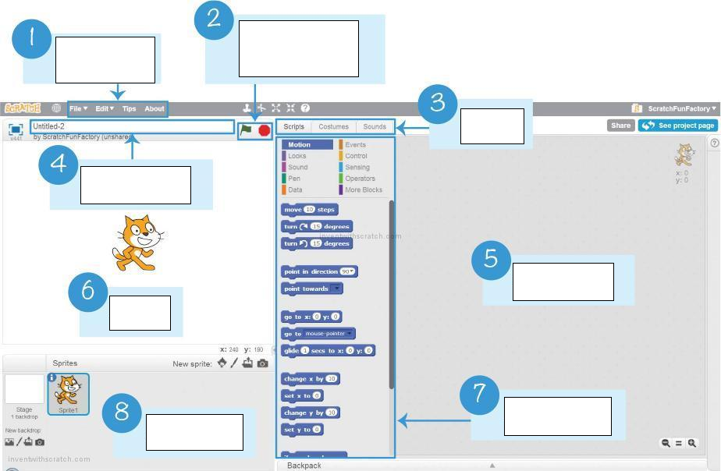

Scoring scheme:
01 mark for each correct label

Summative Assessment:
(Marks: 08)
Q. Define the following:
  - Computer program
  - Event
  - Variable
  - Debugging
Scoring scheme:
02 mark for each definition

Thematic area:

Domain D: Programming

[SLO: CS-06-D-02]
Students will be able to analyze and apply basic programming constructs (e.g. sequence, selection, repetition, variables, inputs/events); by creating simple single-sprite, single-script programs using a visual programing tool.
Cognitive Level:
Analysis

Formative Assessment:
(Marks: 08)
Q. Perform following tasks on the computer using Scratch programming language:
- Move a sprite 10 steps forward
- Complete a square for moving the sprite right, up, left and down by repeating the sequence 10 times
- Change the costume of sprite at every step (total steps 5)
Scoring scheme:
- 02 marks for moving sprite
- 04 marks for each step “right, up, left, down” and 01 mark for applying loop
- 02 marks of changing costume

Summative Assessment:
(Marks: 04)
Q. Derive the output of following piece of code:
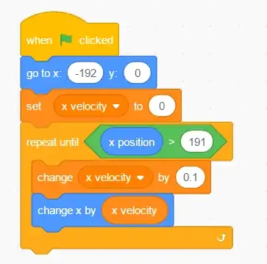
Scoring scheme:
04 mark for depicting the correct movement

Thematic area:

Domain E: Digital Citizenship

[SLO: CS-06-E-01]
Students will analyze the basics of information literacy and digital civility and appropriate uses of technology.
Cognitive Level:
Analysis

Formative Assessment:
(Marks: 05)
Q. Make small groups of students four in each group to discuss the ways to ensure Digital Civility.
Scoring scheme:
01 mark to each student of the group when the group completes the assigned task.

Summative Assessment:
(Marks: 04)
Q. Discuss the importance of Cyber ethic in contemporary global world.
Scoring scheme:
01 mark for each of the idea, argumentation, relevant examples and conclusion

Thematic area:

Domain F: Entrepreneurship in Digital Age

[SLO: CS-06-F-01]
Students will define and analyze entrepreneurship subtypes and summarizer the entrepreneurship process.
Cognitive Level:
Analysis

Formative Assessment:
(Marks: 10)
Q. Write the name, in each circle, of five different stages of entrepreneurial process and define each one of them.

Entrepreneurial Process Model

Scoring scheme:
02 marks for writing the name and defining each stage

Summative Assessment:
(Marks: 06)
Q. “An online shopping mall is operational and people tend to place orders for their desired products.” Which type of entrepreneurship is it, in this case. Also write the advantages and dis advantages of the type you have accessed.
Scoring scheme:
02 marks for identification of scenario
02 marks for advantages
02 marks for disadvantages

